Basketball Unit: Lesson on Passing and Moving, cutting and faking

Zoe Jacobson
V00914557
Faculty of Education, University of Victoria
EPHE 310-A02: Physical Education for General Classroom Teachers
Dan Geneau
November 30, 2020

Lesson: 5 of 8  Topic: Passing while moving, cutting and faking  Grade(s): 5  Materials/Resources:  - 8 cones (two different colours)  - Equal number of bean bags (20+)  - Pinnies  - Basketballs  - Basketball hoops |  | Learning Objectives (TSWBAT):  Psychomotor: Passing the basketball to a partner in offense, cutting to the hoop to shoot.  Cognitive: Think about where your partner is going to move when you pass to them, think about where to move your feet when cutting to the basket  Affective: Teamwork through passing, develop strategies with partners
Parts of the Lesson  Before class:  -Have cones, basketballs, bean bags, and pinnies out and ready to get set up  Activities:  - Plant the Tree  - Monkey in the Middle  - Pass and Cut Drill | Time | Teaching points
Lesson Description  -Set up gym and arrival  Plant the Tree  -Sort students into two teams, each team will have a different colour pinnie to put on their hip  -Each team will go on either side of the gym with their own colour bean bags  -Each team has to run to the opposite section of them and grab only one bean bag, and bring it back/drop it off in their section.  -Children continue to run back and forth collecting as many bean bags as they can and bringing them to their own side  -Teacher sets a timer for 2 minutes and the team with the most bean bags on their side wins  Monkey in the middle game  -Students put into groups of 3  -Place two students about 15 feet away from each other. Place the third student in the middle.  -The person in the middle attempts to steal the ball.  -The two students on the outside are to try to bounce pass the ball to each other without the middleman getting the ball.  Pass and cut drill  -Have all the students sit somewhere in the gym looking at you.  -The teacher (me) will stand at the top of the 3 point line, and the student on the wing on the right side.  -The teacher will start with the ball, then passes the ball to the student on the wing. The student in the middle cannot strip the ball from the player on the wing.  -The teacher will fake going to the left by pivoting to the left, running a couple steps ahead, then quickly pivoting back to the right then running towards the net (see appendix).  -From here get the student to pass the ball when you are close to the net. Then shoot the ball into the net. The student passing the ball to the player by the net should make sure they make eye contact! Bounce passing with make it harder for defenders to reach the ball, passing straight will get the ball to the player faster if there is an opening. The students should practice both,  -Send students off into pairs to take turns doing the activity. Each partner will take turns being the passer and the shooter.  Sharks and Minnows  - Choose two students to be the sharks, these students will not have basketballs. The rest of the class will be minnows and will have basketballs  - The sharks will stand at the half point line in the gym, the rest of the class will stand at either side of the gym behind the line.  - When the teacher yells “go” the minnows will try to dribble across the gym and the sharks will try to deflect their balls out of bounds. If the minnows make it across to the other side with their ball still in hands, they make it to the next round. If the minnow had their ball deflected, they are now sharks as well.  - Last standing student wins that round  Peer Assessment Sheets  -Go through the peer assessment sheets and talk through the cues of each skill before sending them to complete this task  -Split the students into pairs and have them fill out the peer assessment sheets listed below  Closure  - Quick movements and pivots are key while playing offense in basketball  -In order to pass effectively to another player, you need to think about where they are going to be and develop strategies  - What is important when you are going to pivot while cutting? | 5 mins  8-10 mins  8 mins  5 mins  10 mins  10 mins  10 mins  3 mins | -get a few kids to put out bean bags on either side of the gym (one colour on each side), and put cones on lines about 10 feet away from each wall on either side of the gym (while this is happening you can explain to the UDL student the lesson for the day)  -Boundary is the entire gym  -Rules: no purposely running into one another, no guarding bean bags  -After the first round, you can modify it so each child has to carry the bean bag on their head  -Running getting heart rate up  -Stamina/Agility from continuing to try and avoid running into other people for the 2 minutes  -Being able to crouch to get bean bags quickly and then toss them on the other side accurately  -Can modify for older kids and use a hula hoop for placing the bean bags into instead of a section of the gym  -Demonstrate this drill with two students first. The teacher can be in the middle or on the outside.  -The students passing can pass so the ball bounces on the floor, pass straight to them, or fake it.  -The middleman can get as close to the players as they need and can try to steal the ball.  -If the middleman gets the ball, then they switch places with the player they stole the ball from.  -Give a boundary of about 20 by 15 feet. The outside players can move wherever they want in this boundary, the middle player needs to stay between the two outside players  -A safety concern to take into consideration is a ball could hit somebody pretty hard if the middleman gets in the way of the pass.  -Modifications could be made by having two monkeys in the middle instead of one.  -Pick one student to help with the demonstration of the lesson.  -Explain that they are going to learn how to pass and cut.  -Rules: Must pivot to the left and then right, and then run into a lay-up. Partner can pass the ball by bouncing low or passing straight across.  -We are working on passing and moving, the proper footwork for cutting to the basket, practicing offensive positioning.  -Explain to students that it is important to pivot and turn your whole body to the left to maximize the faking.  -When pivoting to the right, remind students AGAIN that you need to turn your whole body when you pivot.  -Can modify this by getting the partner to wait to pass the ball when you are standing right by the net and in a good spot to shoot. Then making the basket.  -While each pair is waiting for their turn at the hoop each student should be watching the players at the net to see what improvements they can make.  -A safety concern that could be addressed is the partners passing too hard and hurting one another. Additionally, pivoting incorrectly could lead to twisting an ankle (if they do not turn their whole body).  -Rules:  - Once a minnow has had their ball deflected, they need to go pick it up and put it away in the basket before becoming a shark. Minnows must dribble best they can and if they lose control and their ball goes out of bounds they become a shark. If a shark goes to throw the ball but the ball doesn’t make it out of bounds, the minnow is still a minnow  - A modification for this game could be to run across the gym without dribbling but instead holding the ball directly in front of them. The sharks can grab the ball (nicely) and throw it out of bounds. Another modification could be having only a few balls between the minnows and having them pass the ball between each other while running to the other side of the gym.  - A safety concern for this game is a child tripping over a basketball that has been deflected  -This activity ties together trying to move around defence without them getting the ball, works on footwork of pivoting when a defender comes near you

Appendix A

Developmental Task Analysis:
Skill: Cutting to the net
- Moving whole body without worrying about foot work
- Without basketball
- Stand forward on three-point line
- Move whole body to face the left
- Take 2 steps forward
- Move whole body to face net
- Run toward the net
- Start to focus on footwork when pivoting
- Without basketball
- Stand forward on three-point line
- Pick up right foot and twist body to the left placing the right foot in front of you
- Bring left foot forward and stand straight for a second to see where your body is
- Pick up left foot and twist body to the right placing the left foot in front of you
- Bring right foot forward and stand straight for a second to see where your body is
- Run towards the net
- Use cutting properly without stopped
- Without basketball
- Stand forward on three-point line
- Pick up right foot and twist body to the left placing right foot in front of you
- Bring left foot forward and run a couple steps ahead
- Pick up left foot and twist body to the right placing left foot in front of you
- Bring right foot forward and run towards the net
- Cutting with the basketball
- With basketball
- Stand forward on the three-point line
- Pass ball to player on the right wing
- Pick up right foot and twist body to the left placing right foot in front of you
- Bring left foot forward and run a couple steps ahead
- Pick up left foot and twist body to the right placing left foot in front of you
- Bring right foot forward and run towards the net
- Catch the ball from your partner who is passing from the right wing and then shoot into the net (no need for a layup at the grade 5 level)

Appendix B
Peer Assessment

Have the students fill out these peer assessments. Split everybody into partners to complete these.

Basketball Unit: Pivoting, Passing, and Offensive Movement

Grading scale: If the skill criteria is consistently present then a ✓ is placed in the box with the corresponding number. If the skill is not present, make comments for improvement.

Pivoting | Passing | Offensive movement
- Turn whole body when pivoting  - Guide with the correct feet  - Taking steps after pivoting (this ensures adequate faking) | - Make eye contact when passing  - Working well with partner  - Pass ball at target well | - Make yourself look big by keeping your elbows out  - Use “sliding” motions  - Keep low and knees bent
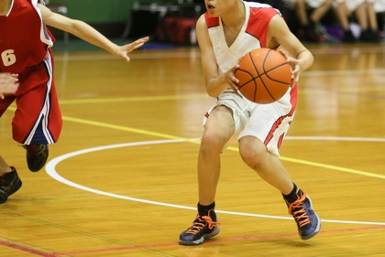  https://proskillsbasketball.com/wp-content/uploads/2019/12/shutterstock_412174627-scaled.jpg | 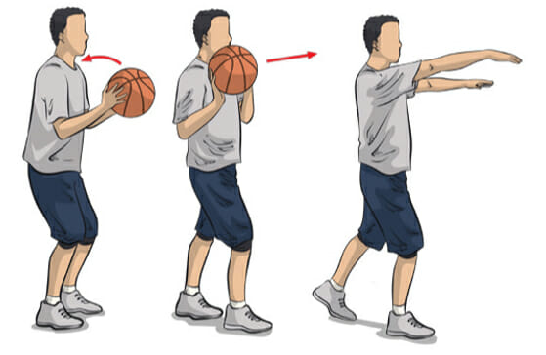  https://www.online-basketball-drills.com/wp-content/uploads/2019/02/fllick-pass-2.jpg | 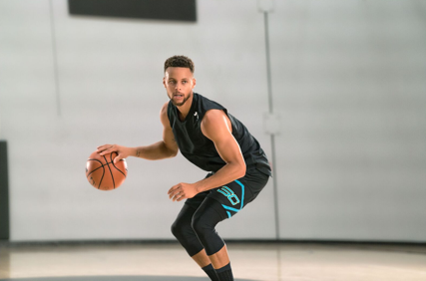  https://images.ctfassets.net/3s5io6mnxfqz/1YjKcUM0xKqwSqoYKacYOG/cc425aab0315af71181288dac884590b/image1.png

Doer:___________________________ Observer:________________________
Cues |  |  | Cues |  |  | Cues
1 | 2 | 3 | 1 | 2 | 3 | 1 | 2 | 3
Comments for improvement:
My partner is great at…

Doer:___________________________ Observer:________________________
Cues |  |  | Cues |  |  | Cues
1 | 2 | 3 | 1 | 2 | 3 | 1 | 2 | 3
Comments for improvement:
My partner is great at…

Appendix C
UDL Inclusion Episode
A child in the class needs to know everything that is going to take part that day because they have ASD and have anxiety when they are in the dark with what is going to happen throughout a lesson. They are fine with most games and activities as long as they are aware of what the games are. My lesson plan shows the use of the UDL by involving the student with ASD in the plans of this lesson while the other students are setting up the gym. This UDL inclusion episode relates to the minimizing threats and distractions section of the UDL guidelines. A safe space is created by setting “alerts and previews that can help learners anticipate and prepare for chances in activities, schedules, and novel events” (UDL Guidelines, n.d.).

References
5 Basketball Passing Drills for Great Movement. (n.d.) https://www.basketballforcoaches.com/basketball-passing- drills/https://www.activekids.com/basketball/articles/11-fun-basketball-games-for-kids- besides-h-o-r-s-e/slide-6
Beck, D. PE Central Cues. (Oct. 24, 2007). https://www.pecentral.org/lessonideas/cues/ViewCues.asp?ID=219
How to Maximize Your Offense and Skill Development. (n.d.)
https://www.breakthroughbasketball.com/offense/motion-offense-build-up-drills.html
Kendall, B and Bekkala, A. 11 Fun Basketball Games for Kids Besides H-O-R-S-E. (n.d.) https://www.activekids.com/basketball/articles/11-fun-basketball-games-for-kids- besides-h-o-r- s-e/slide-6
Minimize Threats and Distractions. (n.d.) UDL Guidelines. http://udlguidelines.cast.org/engagement/recruiting-interest/threatqqs-distractions

